Sprint 2 Plan

DnD Assistant App  
4/21/22–5/3/22

Goal: Create a website that allows users to create a character

User Story:

1. As a player, I want to create a character, so that I can play the game (8)
   1. Choosing (4)
      1. race, class, background, ability score, equipment
   2. pushing character information into database (2)
   3. Scraping information that we don’t have into a JSON (2)
      1. Background
      2. Feats
2. As a player, I want to save my character, so that I don’t have to create a new one every time (2)
   1. Taking previous information and pushing to firebase
3. As a player, I want a walkthrough of the process of creating a character, so that I don’t have to google it (3)
   1. character creation process tips along the way

Team Roles:

* Brian
  + Product Owner, Developer
* Brandon
  + Developer
* Mateo
  + Developer
* David
  + Developer
* Cynthia
  + Developer, Scrum master

Initial task assignment:

* Brian
  + Tips
  + Scrapping
  + Front-end
* Brandon
  + Push final character into Firebase
  + Back-end
* Mateo
  + Front-end
* David
  + Fetch information from DnD api
  + Back-end
* Cynthia
  + Finish creating Roll Dice components
  + Combine the Roll Dice functions and the components

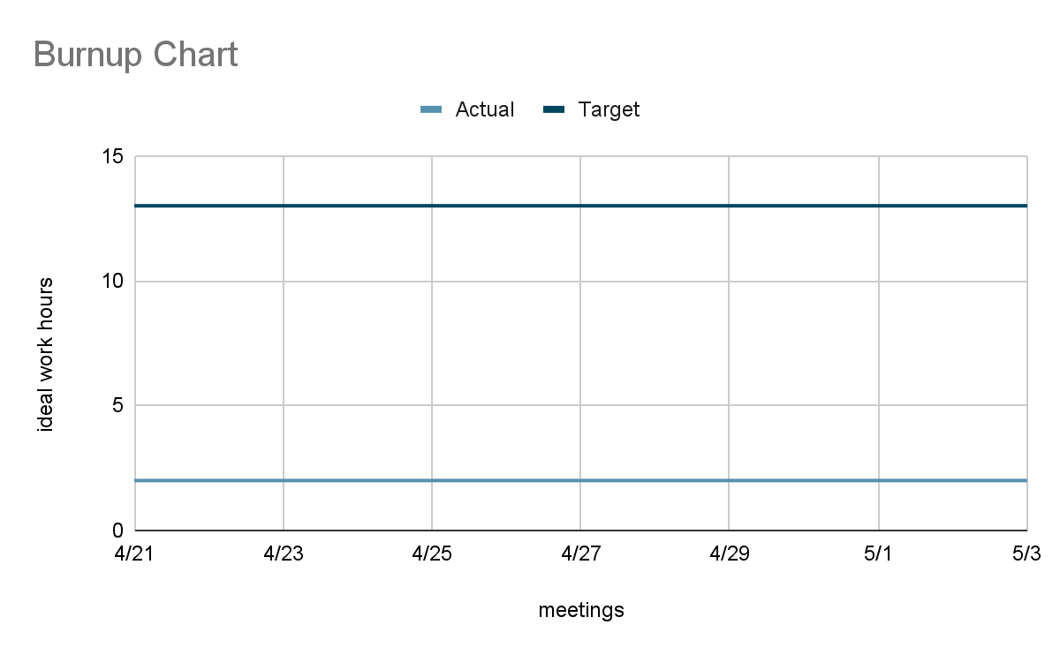

SCRUM board: https://trello.com/invite/dndassistantapp/2ea0443f7a8af527f19901d5f9fc6dc9

SCRUM times:

* Tuesday 9:00 pm
* Thursday 12:30pm
* Friday 4:30 pm (TA)
* Saturday 2:00 pm